Multiple Long-Term Conditions Challenge Fund

Introduction
Guy’s and St Thomas’ Charity is an independent, place-based foundation focussed on the ways in which cities shape our health.
The Charity takes a very applied approach to tackling health inequalities and address complex urban health issues like childhood obesity, long term conditions, air pollution and adolescent mental health. To do this, it works with a multitude of partners, including Guy’s and St Thomas’ NHS Foundation Trust and others to improve the health of people living in the London boroughs of Lambeth and Southwark. It aims to share insights with others tackling similar issues in urban areas.
The charity supports research from across its partner network to examine and develop innovations, or explore new initiatives, which may help to better understand some of the complex challenges facing local communities. The interventions focus on changes at a systems level, changing the urban environments in which people experience health. The wider determinants of health are central to this strategy.

The Charity has a large programme focused on multiple long-term conditions – specifically how we might slow down the journey from one to many long-term conditions by impacting the wider determinants of health. The Charity is looking for researchers who can help to develop our understanding of how and why people progress from one to many long-term conditions, including the living circumstances and pressures experienced in work, housing, personal finances, systemic racism, discrimination and exclusion, and what interventions might help to slow or reduce this progression. More about this programme is available here.

The Charity feels that researchers from across the academic spectrum could conduct research which helps to develop this understanding and would welcome applications from different disciplines, including, but not limited to sociologists, political scientists, epidemiologists, human geographers and others.

Background

Long-term conditions are health conditions for which there is currently no cure, but which can be managed with drugs and other treatments. Recent research, funded by the Multiple Long-Term Conditions Programme at Guy’s and St Thomas’ Charity, has explored people’s progression from one to many long-term conditions in an urban environment and some key findings are:
- Although multiple long-term conditions are seen in older age and linked to frailty, this is not just a problem of old age. In Lambeth & Southwark people are developing their first condition in their 30s and, if they progress to a second condition, this happens in their 40s. Large numbers of people with multiple long-term conditions are of working age.
- People experience MLTCs in complex ways. Focusing on individual diseases underplays the cumulative impact on individual health and wellbeing and the wider impact on individual’s lives.
- People’s progression from one condition to many varies significantly, influenced by mix of health and social factors – including income, ethnicity and social context.
The research underscored the stark inequalities in our inequalities amongst our population and the significance of the wider determinants of health (for example housing, employment, financial circumstances) on the progression of long-term conditions, for example:
- Black communities make up 18% of the local adult population, but carry 27% of the disease burden of living with multiple long-term conditions.
- People living in the most deprived areas in Lambeth and Southwark are developing conditions on average 10 years earlier than those living in the least deprived areas.

The current pandemic has exacerbated existing issues. People who already experienced the greatest inequity including people on a low income and people from the Black and ethnic minority communities, are more likely to contract the virus and more likely to die from it. Structural systems issues, which disproportionally affect them, such as rising unemployment, insecure housing, food insecurity and being in lower paid jobs, where you are less able to protect yourself, are all heightening vulnerability and contributing to worse outcomes. This situation can be compounded for people experiencing intersectional inequalities (e.g. combining gender, ethnicity or disability to name only a few protected characteristics).

It was apparent from the literature that evidence is limited both for the determinants of progression to MLTCs and for the effect of modifying social risk factors on health outcomes. Previous studies investigating the determinants of multiple long-term conditions have produced inconclusive findings and have been largely limited to cross sectional studies.
In healthcare, there has been a lack of longitudinal studies to help us understand the most common disease clusters, causative factors and rate and nature of progression. To address this point, the Charity has funded a large research project being led by Dr Mark Ashworth at KCL, which is examining the prevalence and pattern of long-term conditions amongst people registered in primary care data over a 10-year period.
The KCL research project will give us much more understanding of what multimorbidity people experience in Lambeth and Southwark, and to an extent, the ‘when’ and ‘who’ (when are people progressing and how does this play out across different groups). The study (and other studies like it in the evidence base) does however have limitations in that it is a secondary analysis of primary care data, so therefore reliant on the quality and nature of recording, as well as people being identified in primary care. These gaps may be something that could be examined further through this call (see further detail below in Scope).
What drives progression? The role of the wider determinants of health

As noted, the KCL study will help us answer many important questions regarding multimorbidity in our place, but it will be limited in developing an understanding of the very important questions of ‘how’ and ‘why’ people progress to multimorbidity.
In terms of these questions, below is Dahlgren and Whitehead’s model of the main determinants of health. The Charity is most interested in systemic drivers of health, as shown in the outer two bands of this model;
1. Living and working conditions, and
2. General socio-economic, cultural and environmental conditions.
Research which helps to develop a deeper understanding of the experience and influence of these factors and how to address them effectively is of prime interest in this call. Further detail on themes in specific areas is included below in ‘Scope’. To note, the Charity will also be interested in proposals which explore these structural themes affecting health in relation to the impact of Coronavirus.
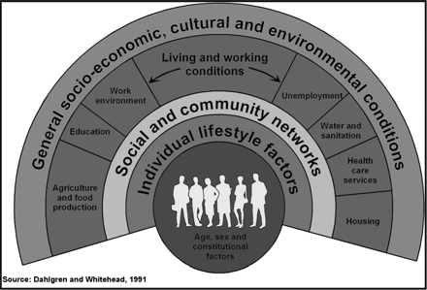

What are effective interventions?
The next step from understanding the development of multimorbidity is of course the question of how we can effectively intervene to prevent or slow progression from a single long-term condition to multiple conditions.
There is currently little evidence about what interventions could help to slow down the trajectory to multiple long-term conditions, including those that address the social determinants of health and/or relate to health inequalities. There is real need to develop the evidence base around how we might influence people’s health outcomes through intervening in areas like finance, employment and housing (see further detail below). Proposals in this area should take account of Coronavirus developments.

Wellbeing and multimorbidity
Evidence is not available to quantify the causal association between changing social risk factors and either proximal health risk factors or ultimate health outcomes/ impacts. The Charity is currently exploring measuring the impact of its social determinants interventions on wellbeing as a proximal outcome (see causal pathway below), as measured by the Warwick Edinburgh scale (SWEMWBS, 7 items) or alternative mental health or wellbeing scales (tbc). Research exploring the relationship between wellbeing and multimorbidity is therefore in scope for this call.
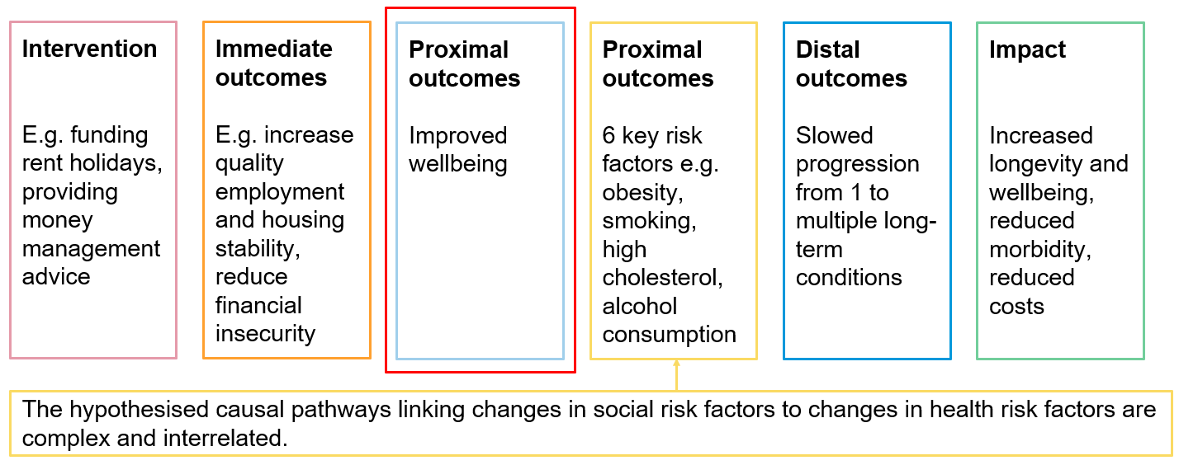
Figure 1: Hypothesised casual pathway of MLTC programme impact

Finally, it should be noted, that in respect of both evidence related to progression and interventions, very little research is focused on adults of working age (as opposed to older populations), although our data suggests this is the period in people’s lives when they progress from one condition to more.

The Scope
The focus of this call is for preventative efforts to slow progression for working age adults, who live with one health condition and are at risk of developing many. This requires us to:
- examine how circumstances and environments (e.g. employment, finances, housing) impact wellbeing or the progression from one long-term condition to a second or third long-term condition, in working age adults in Lambeth and Southwark
- prioritise groups most likely to experience health inequity, including people from Black, Asian and Minority Ethnic communities and those on a lower income and people experiencing intersectional inequalities (e.g. combining gender, ethnicity or disability to name only a few protected characteristics).
- explore how social interventions, wellbeing / stress and multimorbidity are linked
- understand how this progression could be slowed down or halted through interventions.

Working with experts, the Charity has developed the following programme focus on 32 long-term conditions and 6 risk factors.

The scope of the call is focused on:
- Research which helps us to understand in greater depth people’s experiences of multi-morbidity, including the influence of the social determinants of health and health inequalities – e.g. primary data collection, action research/applied research, ethnography and other types of qualitative research
- Research which provides evidence about which interventions are effective (in terms of improving health outcomes) and for whom – e.g. Evaluative studies of interventions, Feasibility or Pilot studies
Research within Lambeth and Southwark would be preferred, however research with populations outside of Lambeth and Southwark will be considered if the knowledge generated can be related back or compared to these local populations (for example in similarly urban areas).
We are looking for applications from across the university, including but not limited to social sciences and medical sciences. We welcome cross-faculty partnerships.

Particular areas of focus and interest for the Charity
As our programme has matured, through working with local partners and people living in our place, we have developed several areas of interest. In terms of specific themes, our programme is evolving as we learn, so this list is not exhaustive, however we would be interested in any research submissions which explore the following:

Wider determinants of health
Employment | We are interested in how the health of our target cohort can be impacted in relation  to work and work seeking activities, particularly:  - Economic Empowerment of residents through work including Job Creation, Access to Roles and New Business Support  - Work with employers to identify and expand their role in the recovery and the health and wellbeing of low-income employees  - Skills and Employment: Back to work infrastructure  - Policy influencing
Housing | - Health of our target cohort in the bottom third of the private rented sector  - Shift specific characteristics of private rented sector towards health equity: Access, Affordability, Conditions, Security of tenure, Ongoing support  - Ways to shift power and support health through tenants’ voice and empowerment
Financial circumstances | - Preventing financial difficulty & increasing resources for people to manage their health, for example through cash flow management, welfare benefits and legal issues, reducing ‘poverty premium’  - New approaches, including trials of projects & policy interventions, to break the two-way connection between ill-health and financial difficulty  - In the context of people experiencing recurring financial crises, the most effective ways to achieve long-term behaviour change interventions  - Cross-sector collaborations between organisations trusted by our target cohort and new settings to address financial health issues (e.g. across two or more of: employers, creditors, community groups and charities, health settings, financial services, digital/media platforms, etc)
Other | - How social and material relations, such as racism, gender and income inequity, influence progression  - Building on the above in terms of racism, people’s experiences of racism and unconscious bias and the relationship this has with accessing statutory services and getting support  - Understanding the wider health economy in Lambeth & Southwark; e.g. the experience and role of alternative therapies in specific communities, the role of faith-based organisations in supporting people’s health  - The contribution of urban environments to onset and deterioration and specific responses to this  - The contribution of events in the working-age life-course to health or decline (e.g. redundancy, having children)  - Developments around digitalisation and how to ensure these maximise benefits and do not widen inequalities

Healthcare and other services | - Insight into self-management’ by different groups and how this can be effective  - Experience of the relationship with healthcare and other statutory services by specific groups; for example the extent that they are experienced as trustworthy and how this relates to accessing services early and preventatively. How experiences of racism and unconscious bias feed into this.  - Improved early clinical care (including integration) for specific pathways, see below  - Focus on Common Mental Health Conditions and Chronic Pain as gateway conditions; including the lived experience of these conditions and impact on daily life amongst working age adults  - Focus on diabetes and hypertension, as conditions more commonly experienced by people from Black Communities (along with chronic pain)

Out of scope
This call is not focused on people over the age of 65 or people who are at the end of their lives. It is also not focused on children or adolescents.
Clinical studies and studies of the biological mechanisms underpinning long-term conditions are out of scope, including those relating to Coronavirus.
Epidemiological studies, data linkage and analysis is out of scope unless the dataset explicitly links clinical and social information.
Diagnosis or management of individual long-term conditions is also out of scope unless they are explicitly examining the interrelationship between that long-term condition and people’s circumstances and risk of developing another long-term condition. We would particularly strongly encourage that applications focused on this area also examine issues of inequity in relation to these questions, for example by focusing on Black or other minority ethnic groups.

Eligibility
The principal investigator must be an employee of a partner organisation of King’s Health Partners (King’s College London; King’s College Hospital NHS Foundation Trust; South London and Maudsley NHS Foundation Trust; and Guy’s and St Thomas’ NHS Foundation Trust).
The Multiple Long-Term Conditions Challenge Fund encourages collaboration with partners outside of KHP, where this provides value to the research. We strongly encourage partnerships with practitioners in our place who seek impact in our local communities. Applications must be led by a researcher within KHP but can collaborate more widely. For example, where additional relevant expertise and data is available externally, applications should consider including co-investigators or collaborators who can provide this.
Funds can be used to cover the directly incurred costs of such collaborators where necessary and should be included in the budget.
External researchers interested in collaborating in this scheme should contact the relevant researchers within KHP. For those who do not have a collaborator within KHP but are interested in making contact, please contact khpresearchoffice@kcl.ac.uk with a description of your research interests, CV and expertise/ access to patients/ data and any other resources which may be relevant. We will then pass your details on to relevant researchers within KHP who may wish to discuss the opportunity for collaboration.

Funding Available
Call one and two have concluded with 7 projects funded (https://www.gsttcharity.org.uk/get-involved/news-and-opinion/news/seven-new-projects-explore-long-term-conditions-urban-places ) .
We are pleased to launch a third call for projects. For round 3 we have £700K available to award. Projects can be up to £175K with a maximum duration of 24 months. We welcome projects of smaller value or duration where appropriate.

Key Dates

Round | Call opens | Submission Deadline | Panel Meeting | Projects start by | Maximum Project Duration
3 | November 2020 | 5pm on 25th February 2021 | May 2021 | Within 3-6 months of outcome | 24 months

Guy’s & St Thomas’ Charity, From one to many - Exploring people’s progression to multiple long-term conditions in an urban environment, 2018. https://www.gsttcharity.org.uk/sites/default/files/GSTTC_MLTC_Report_2018.pdf
Richmond Group of Charities, “Just one thing after another” Living with multiple conditions , 2018. https://richmondgroupofcharities.org.uk/sites/default/files/final_just_one_thing_after_another_report_-_singles.pdf
The Academy of Medical Sciences, Multimorbidity: a priority for global health research, April 2018, https://acmedsci.ac.uk/file-download/82222577
Dahlgren, G & Whitehead, M (1991)“What Can Be Done About Inequalities in Health?”

