Centre for Translational Medicine
Pre-doctoral Clinical Research Excellence Fellowships
(p-CREFs)

Guidance for candidates

Overview
Applications are now open for the Centre for Translational Medicine (CTM) pre-doctoral Clinical Research Excellence Fellowships (p-CREFs). This scheme offers one year pump-prime funding to allow protected research time and training for health professionals working in translational medicine. Development of external funding applications to support a doctorate is expected during the year, and securing further research funding represents a key success metric of the fellowships.
It is anticipated that during the 12-month period of the fellowship, candidates will:
- Actively pursue their research project, generating data to contribute to a doctoral fellowship application.
- Engage in research and professional development opportunities, including via the CTM, King’s Clinical Academic Training Office, locally in departments, across KHP and beyond, to support their development as a clinical academic researcher.
- Prepare scientific/research data to present at meetings where relevant opportunities arise.
- Prepare a research fellowship application for submission to an external funding body, such as a Research Council, Charity, NIHR, to support a period of doctoral research.
Strategic fit
Funding seeks to support fellows to develop and deliver on projects in translational medical research, particularly studies of disease mechanisms in humans and the translation of these insights into early detection and interventions. This includes use of diagnostics and devices, and the development of proof of concepts, such as through early phase clinical trials of new treatments and development of advanced therapies (see figures 1 and 2). Fellows’ research projects must align to the priority areas and themes summarised in Figure 2 and demonstrate clear contributions to the strategic priority areas for health research at the KHP organisations. Pre-clinical research projects (e.g. animal models) are not eligible.
We particularly encourage applications that:
- aim to harness combined strengths across KCL faculties and KHP organisations
- bring together multidisciplinary, cross-partner and/or cross-faculty research and expertise, which may be reflected in the supervisory team
- connect mental and physical health (and/or links to the NIHR Maudsley BRC)
Figure 1: Stages in the translational pipeline the call seeks to accelerate:
Figure 2: Priority areas for funding:

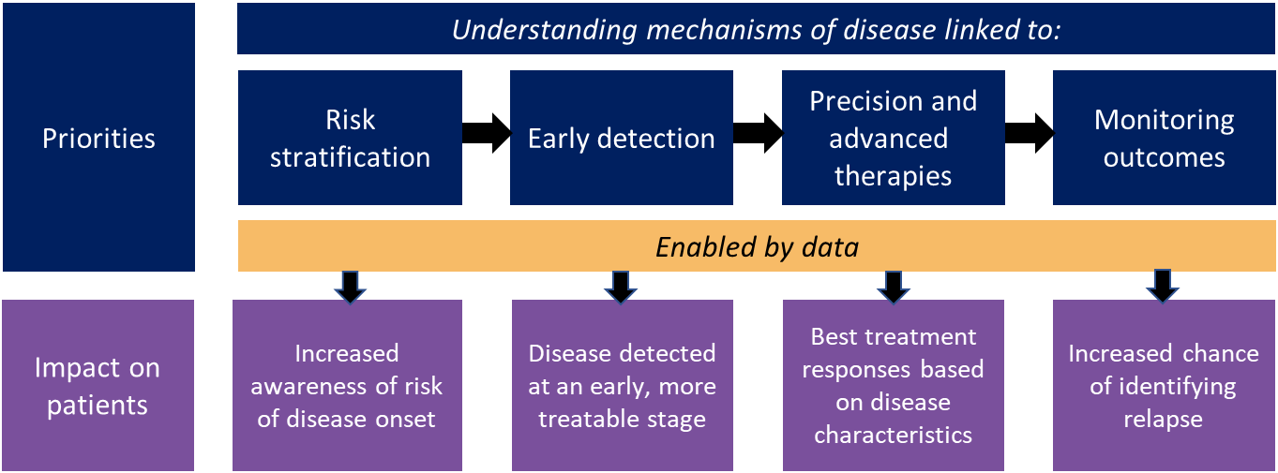

Funding available
This scheme provides:
- A full-time matched salary for fellows (up to a maximum of £75,000 including on-costs), according to the level of experience
- A consumables budget of £5000 (which can include funds towards PPIE activity)
- A bursary of up to £1000 towards meeting/conference/advanced training course fees and associated travel and subsistence.

Candidate Eligibility

- Health professionals (registered with a UK health professional regulatory body) are eligible to apply, including, doctors, dentists, nurses, midwives, allied or other health professionals. Researchers/scientists who are not registered health professionals are not eligible.
- Applicants should have a relevant professional qualification or degree with distinction/honours or previous research experience.
- The aim of the fellowships is to provide protected research time embedded and supported in the optimal environment for clinical academic career progression. Fellows should be based wherever is best for the type of research activity, optimal research supervision/ mentoring, support structures/professional development, requirements for professional registration and validation etc.
- These fellowships are offered at 12 months full-time. Continued clinical activity (up to a maximum of 2 PAs/0.2 FTE/20% of time) is permitted only when relevant to the research project.
- Applicants must not have registered for, or completed, a PhD or MDRes, nor have registered for an MPhil with the expectation that this will progress to a PhD.
- This scheme aims to support researchers who are intending to pursue a clinical academic career – i.e. maintain both clinical professional activity and research in the long-term. An outline of how both previous experience/training and future plans demonstrate this is required in the application.
- These fellowships are designed to support candidates towards embarking on doctoral research, not Masters degrees.
- We particularly welcome candidates from backgrounds underrepresented in clinical academic careers.

Supervision
Fellows will be supervised by scientists and/or clinical researchers with a proven track record of translational research, and previous experience of successful supervision of personal fellowship-holders. Supervisors must be employed by one of the organisations of King’s Health Partners (KCL, GSTT, KCH or SLaM), and fellows should be embedded in a vibrant academic environment which will support their clinical academic progress. Dual supervision, including cross-partner and cross-faculty supervision, is strongly welcome.
Successful applicants will have access to a programme of research training and career development through King’s Clinical Academic Training Office (KCATO) and other entities across the KHP organisations. This will include mentoring, research skills training, professional development and grant/publication writing support.
Supervisor eligibility
- The first supervisor must be research-active staff member employed by one of the KHP organisations. Second and/or third supervisors, either from within or outside KHP, are permitted.
- At the point of application, fellows should identify a primary and second supervisor as a minimum. At least one supervisor must be a KCL employee or hold an adjunct appointment.
- Supervisors should have a track record of successful supervision of health professional researchers, and supporting them to obtain external competitive fellowship funding.
- At least one supervisor must be a clinical academic health professional.

Details of supervisors who have expressed interest in supervising a fellow for the 2024/25 cohort can be found on the KHP website:
https://www.kingshealthpartners.org/our-work/centre-for-translational-medicine
Please note that only one application can be submitted by either a prospective fellow or a first supervisor.
Assessment criteria
Applications will be assessed against a number of criteria including project (e.g. feasibility, strategic fit, contribution to health equity, PPIE, value for money, contribution to patient/community outcomes), person (including research experience and potential, training plan), and place (including local environment and opportunities for academic development, supervisory team, networks and mentoring).

Application Process and Key Dates

There are two stages for candidates to apply to the p-CREF fellowships.

- Candidates review the list of supervisors who have expressed an interest in hosting a fellow in this cohort. Candidates approach potential supervisors, sharing a recent CV and cover statement, to discuss potential projects and hosting arrangements.

Deadline: Friday 22 March 2024

- Fellows and supervisors work up an application form

Application deadline – Monday 22 April 2024 (5pm)

- Interviews – w/c 3 June 2024

- Fellowships start – Autumn 2024

Applications should be submitted through the online form:
https://qualtrics.kcl.ac.uk/jfe/form/SV_9YKSweTImdi0Djw
We are holding an engagement Q&A session – date TBC. To register to attend this, please sign up via registration form: https://forms.office.com/e/Gcjbv8SVDu
Queries can be sent to the KCATO team delivering the call via kcato@kcl.ac.uk.

